Exp. 2. Simulation of Density of States of Quantum Well Structure with Various Nanometer Thickness.
Aim: To simulate density of states of quantum well structure with various nano meter thickness
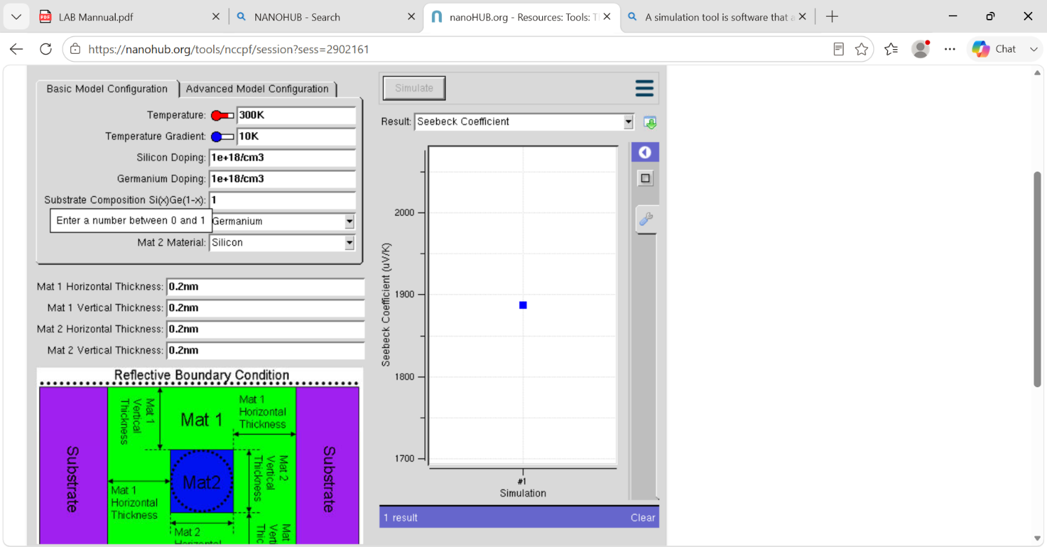
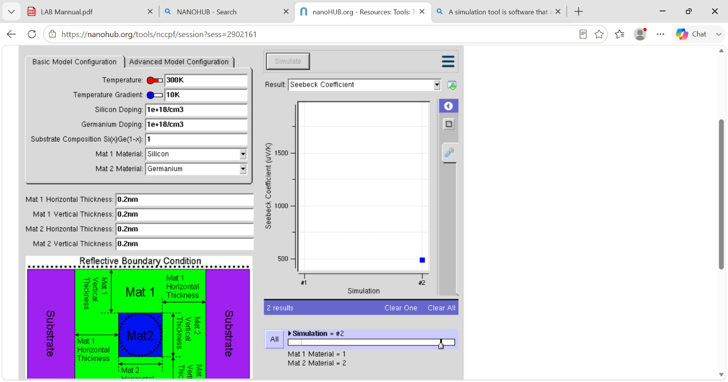
Case Study 1: Simulate the density of states of quantum well of thickness 0.5 nm
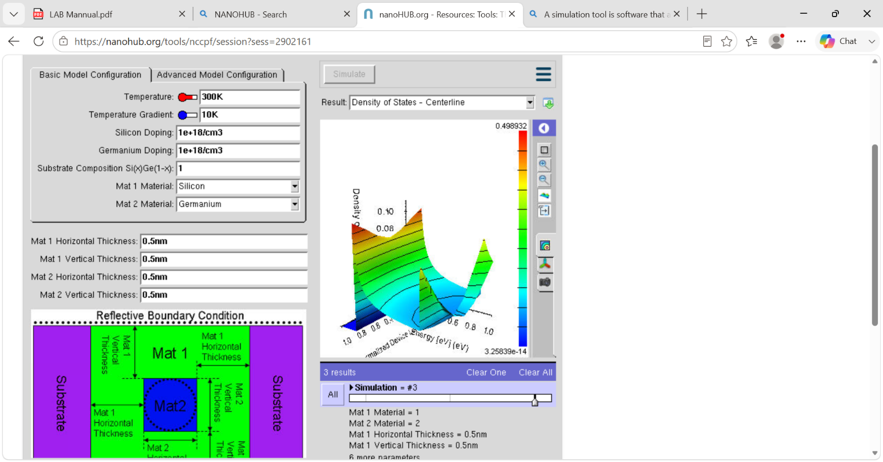
Case Study 2: Simulate the density of states of quantum well of thickness 0.6 nm
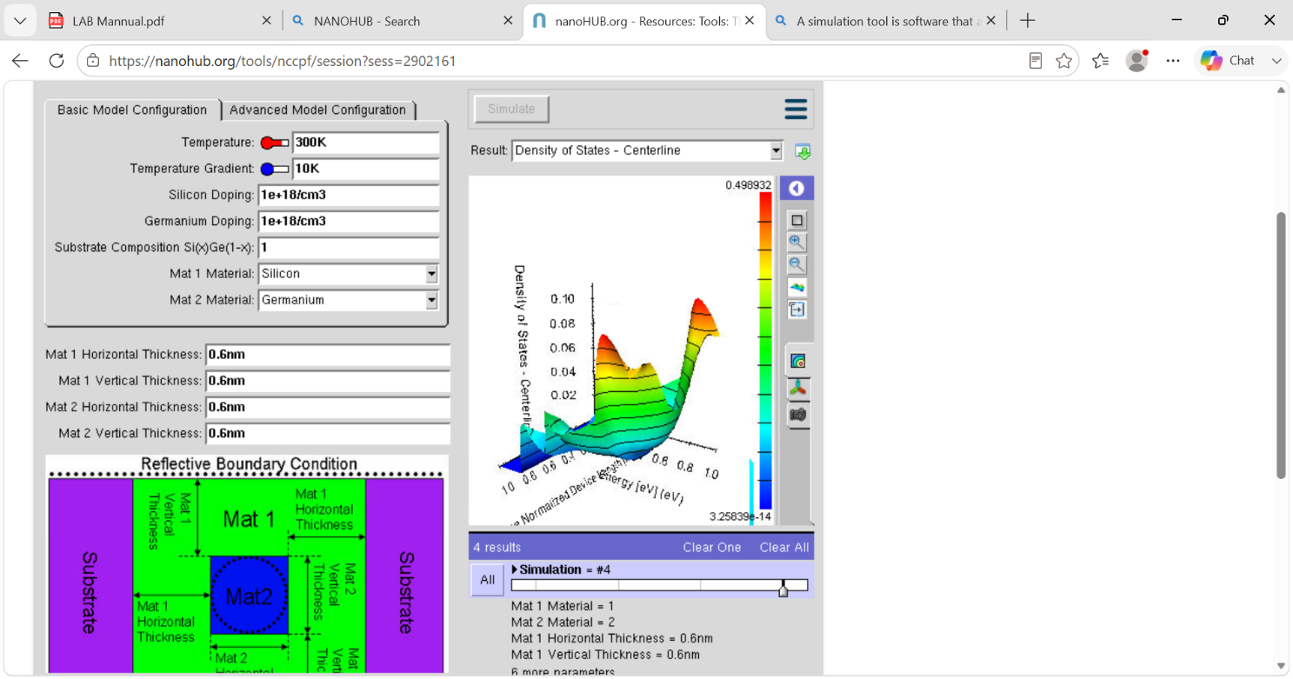

Exp. 3. Simulation of Energy States of Quantum Dot using NanoHub
Aim: To obtain the energy states of Quantum dots.
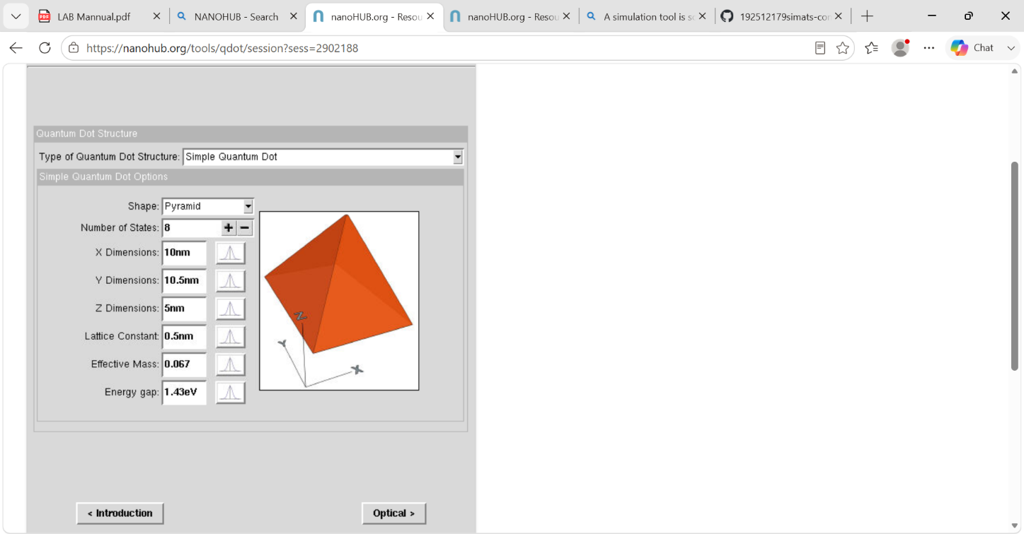
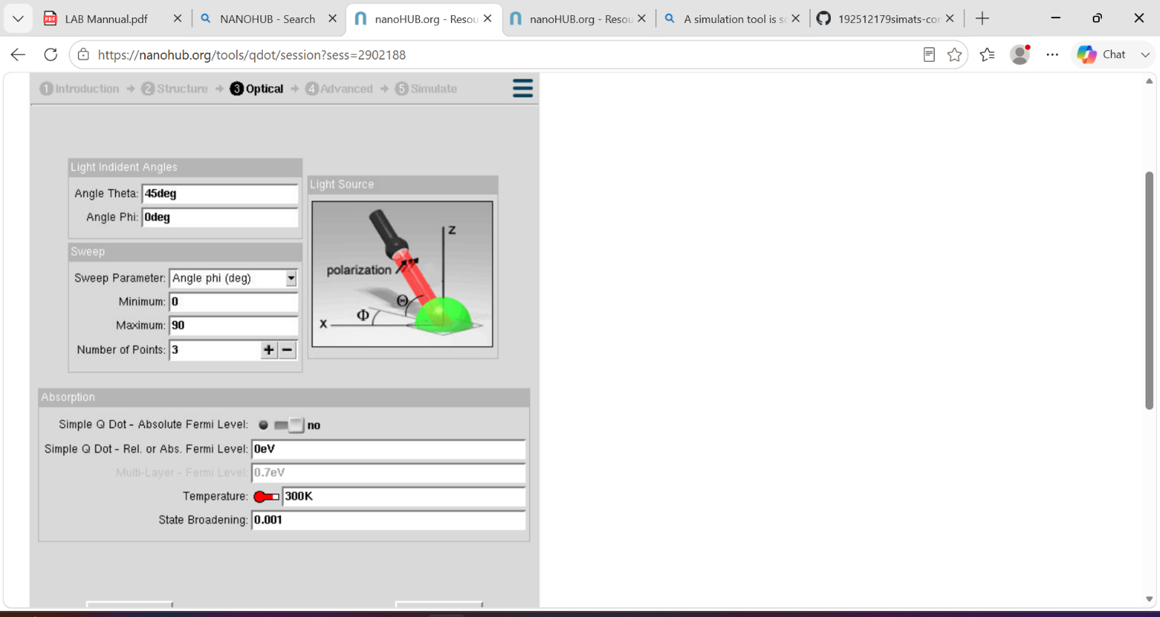

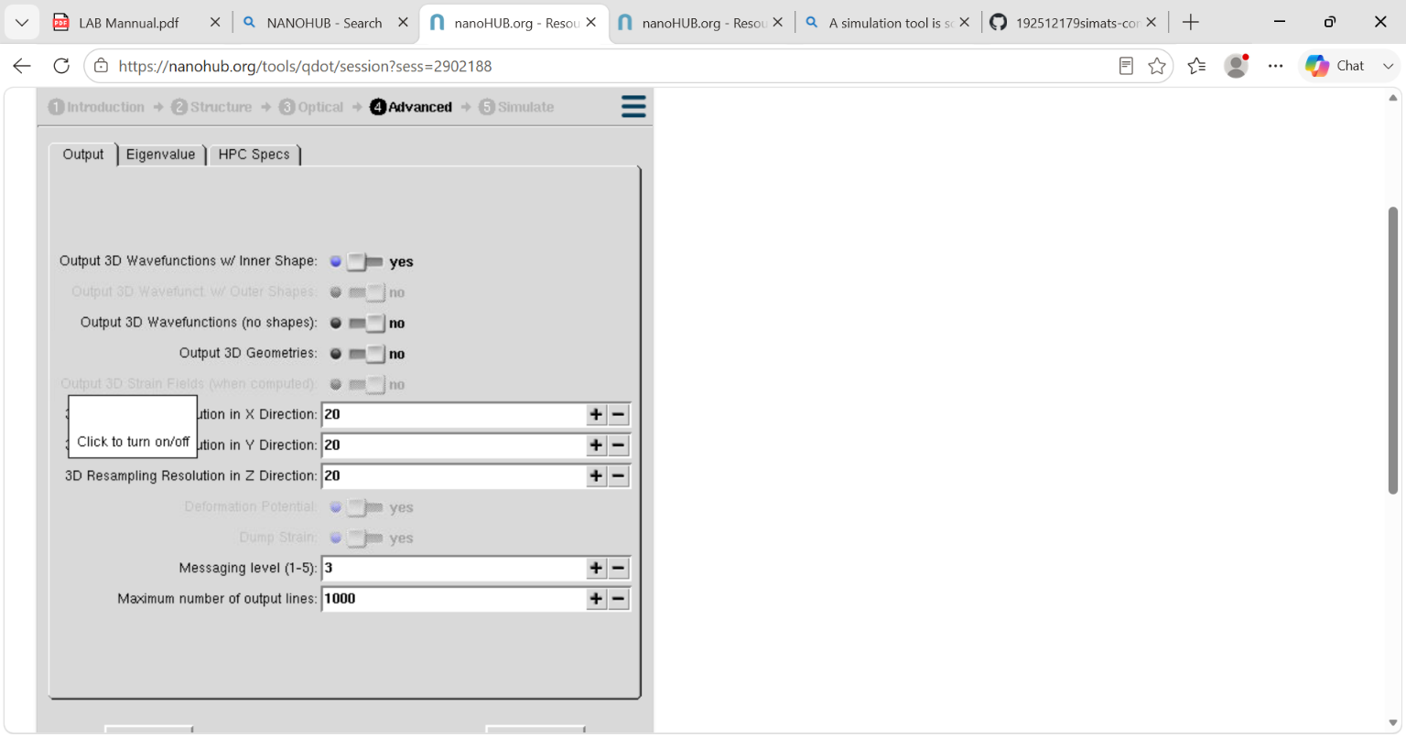
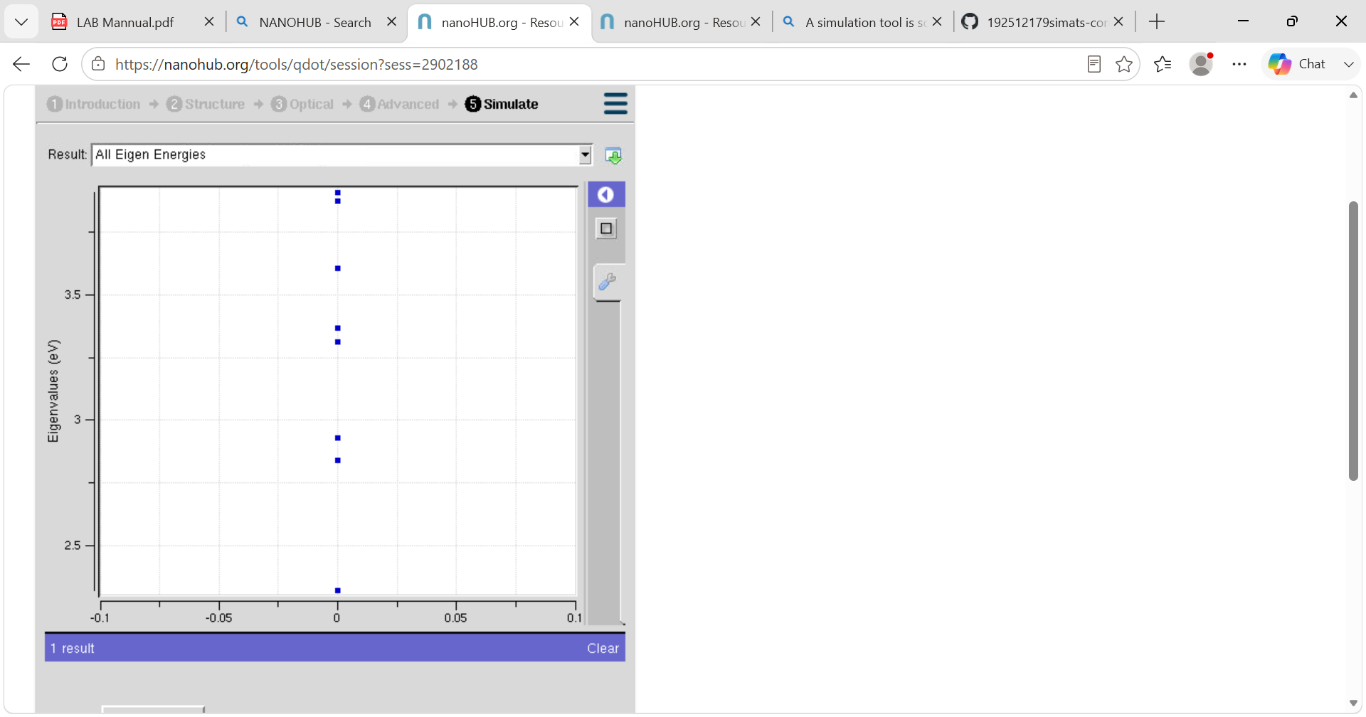

Case Study 1: Simulate the energy states of cylindrical quantum dots of X=15 nm, Y = 10.5nm and Z = 8nm
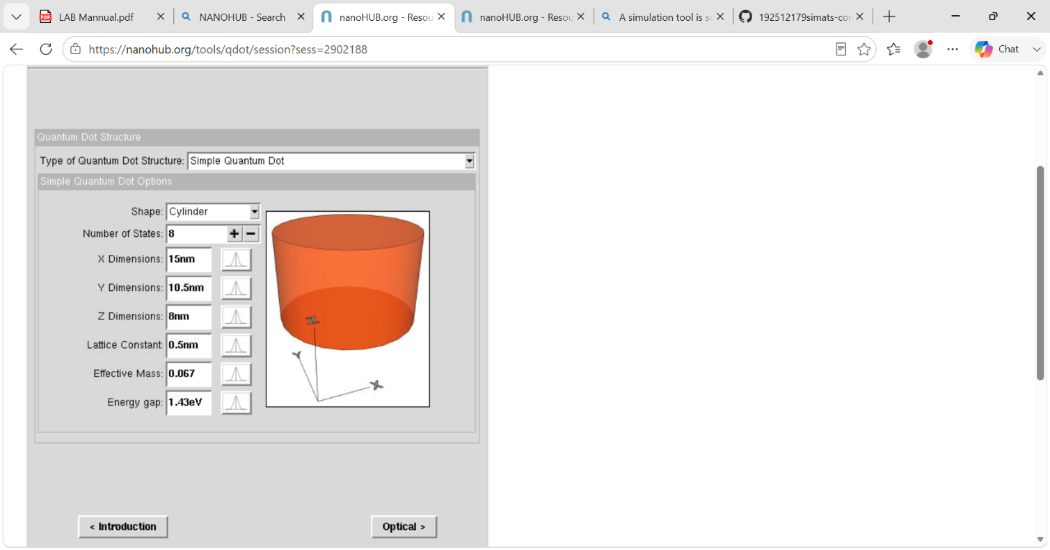
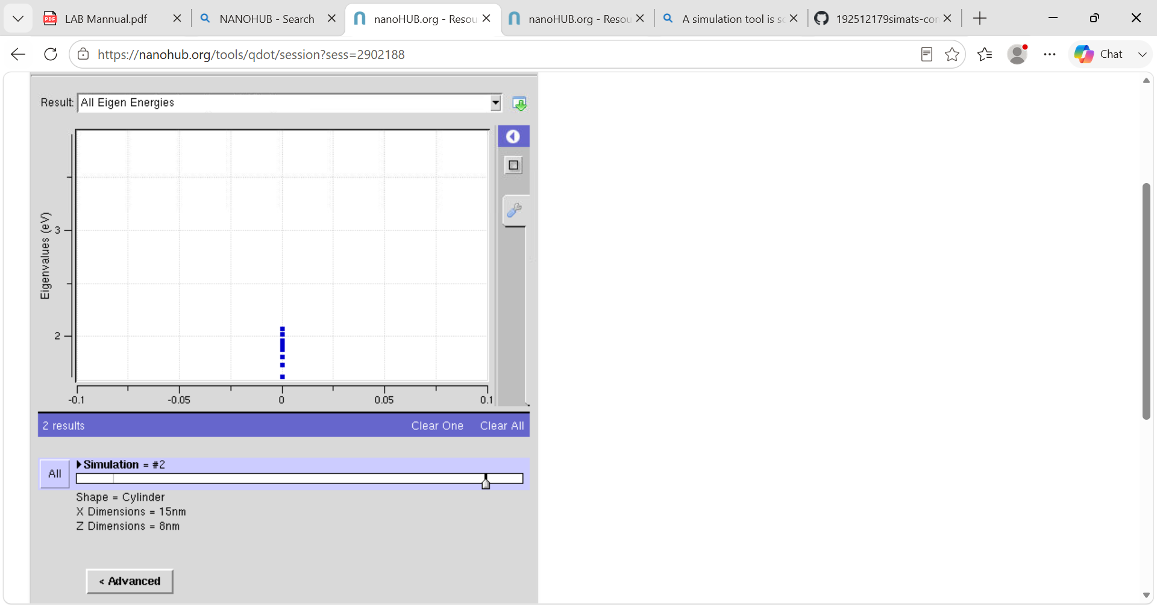

Case Study 2: Simulate the energy states of two layer cuboid quantum dots
